[FCM](https://firebase.google.com/docs/cloud-messaging/) Cloud Messaging dossier

**Organization**



**Installation integration**

Install as follows:

1. Import in project Fcm
2. Click on the Event Log message

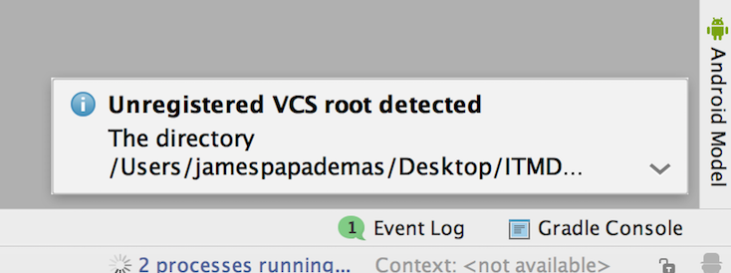

1. Choose Ignore

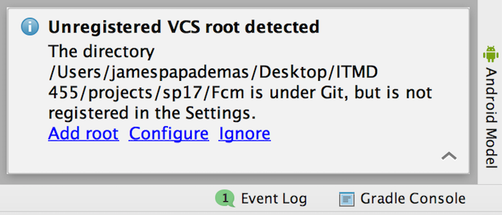

**Run Application**

1. Enter desired data. Token will be generated (check logcat file) . Two data values will be stored in the PapaBase FCM app server. For one value an insert token will be inserted into the **users** table via a Php post and another value will be posted on an update to the **users** table with the username taken from the Email entry (check code + php files).



Email will be a data value entered into the server



1. Press REGISTER button. Following shows.



**Send a Message!**

1. Go to <http://www.papademas.net/fcm/push_notification.php> and choose from the pull down menu the username you will to send a message to. Sort is by id so the latest users are stored in toward the bottom of the listing. Enter in a desired message then press the Send button.



1. Check your device for the message. Note as you repeat a run or start fresh with a run of you app even with the same AVD chosen you may have a renewed token generated and entered in the **users** table on the PapaBase server so just remember to enter in a new Email in the text field.

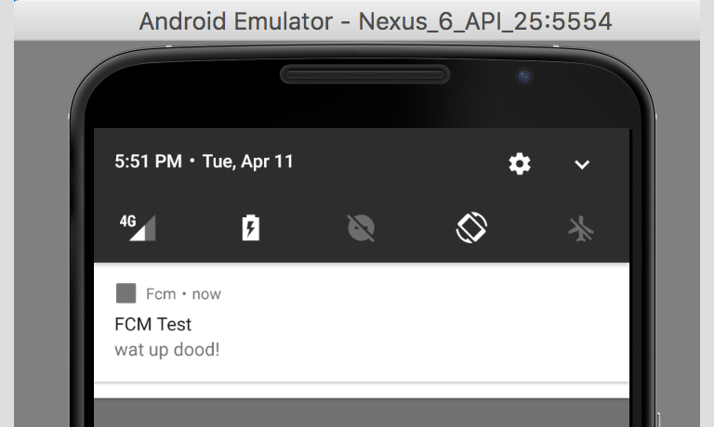

Check out the Php files to see the code logic for registration insertions in the users database table (register.php), updates (update.php) and for sending push notifications (push_notifications.php).

Here is schema breakdown from **fcm** database. Table meta data follows for **users** table.

Url: <http://www.papademas.net/phpmyadmin/>

Login:

Username- fcmuser

Password- fcmpass

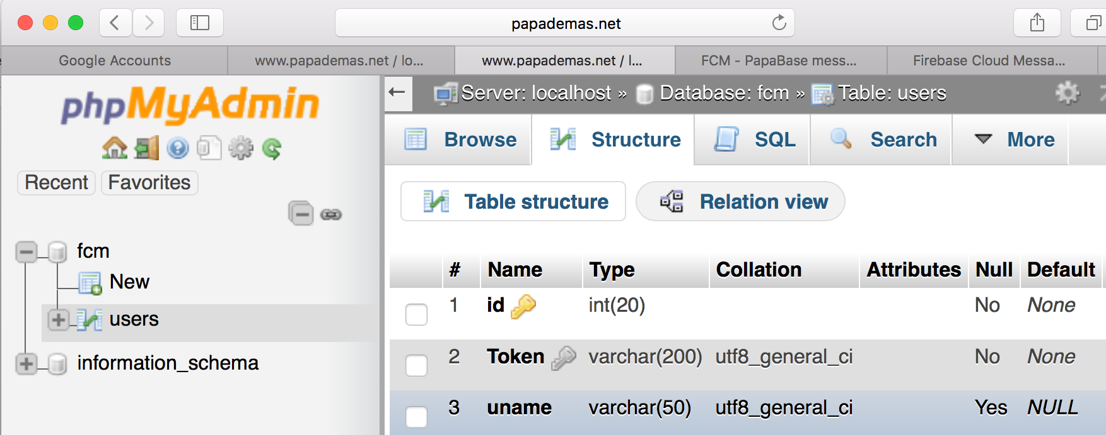

For instructions on how to do this process yourself including setting up a database locally or a designated server consider these helpful links!

Main project references:

Video tut:

<https://www.youtube.com/watch?v=LiKCEa5_Cs8>

git hub repo:

<https://github.com/miskoajkula/Fcm>

Registration form:

<http://www.androidhive.info/2012/01/android-login-and-registration-with-php-mysql-and-sqlite/>